1. Features on top of the dashboard,

Select the time period for which you want the data to be shown.

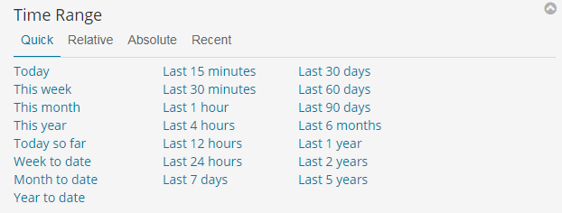

To go full screen on the browser.



Search for specific data. E.g., Typing ‘food’ and pressing enter would make all the charts in the dashboard to show stats for only those tweets having the word ‘food’ in them. In order to make complex searches, ‘AND’ and ‘OR’ keywords can be used.

E.g., food AND (medicine OR water) would show only those tweets having ’food’ and either of ‘medicine’ or ‘water’ in them.

**To remove search filter, clear the search bar and press enter.**

Turning on this feature would refresh the dashboard continuously based on the chosen time interval.

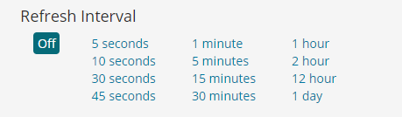

Using this, you can select a field and filter values from it. Filters are applied to the entire dashboard.

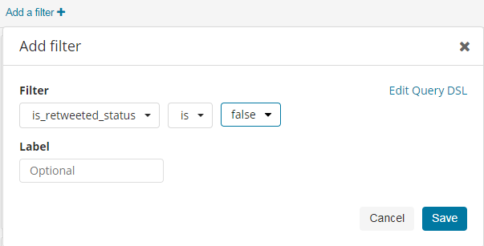

**Make sure ‘Turn on query features’ is on**, in order to use ‘AND’ and ‘OR’ keywords to make complex queries. Else, ‘food AND water’ may be considered as a single full term to be searched for.

1. Other features in the dashboard,

Clicking on a component (bar/point) of any chart or a value from any table (like list of tweets) would apply that value as a filter to the dashboard.

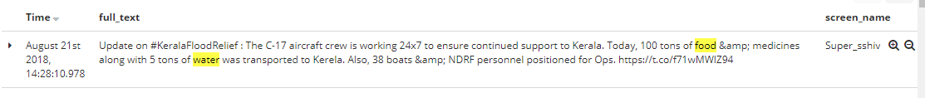

Hover on any value in the table to get this zoom icon. Clicking on this would apply that value as a filter for that field. Here, if clicked, screen_name = Super_sshiv would be applied as filter, and only tweets from that screen_name (user profile) would be shown in the entire dashboard.



Filters applied on the dashboard are displayed on top of the dashboard. Hover on this to get the delete icon to remove that filter. This is general way to remove any filter.

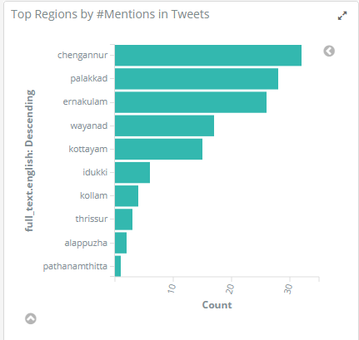

Similarly, click on bars in charts to apply filters. Here, clicking on first bar would add a filter to show only tweets having ‘chengannur’.



Above tablet would appear on top of dashboard indicating that corresponding filter is applied to the dashboard.

1. Content of the Dashboard.

**Data shown in the dashboard is with respect to the search query, filters added and time period selected from the top of the dashboard. Refer previous pages.**

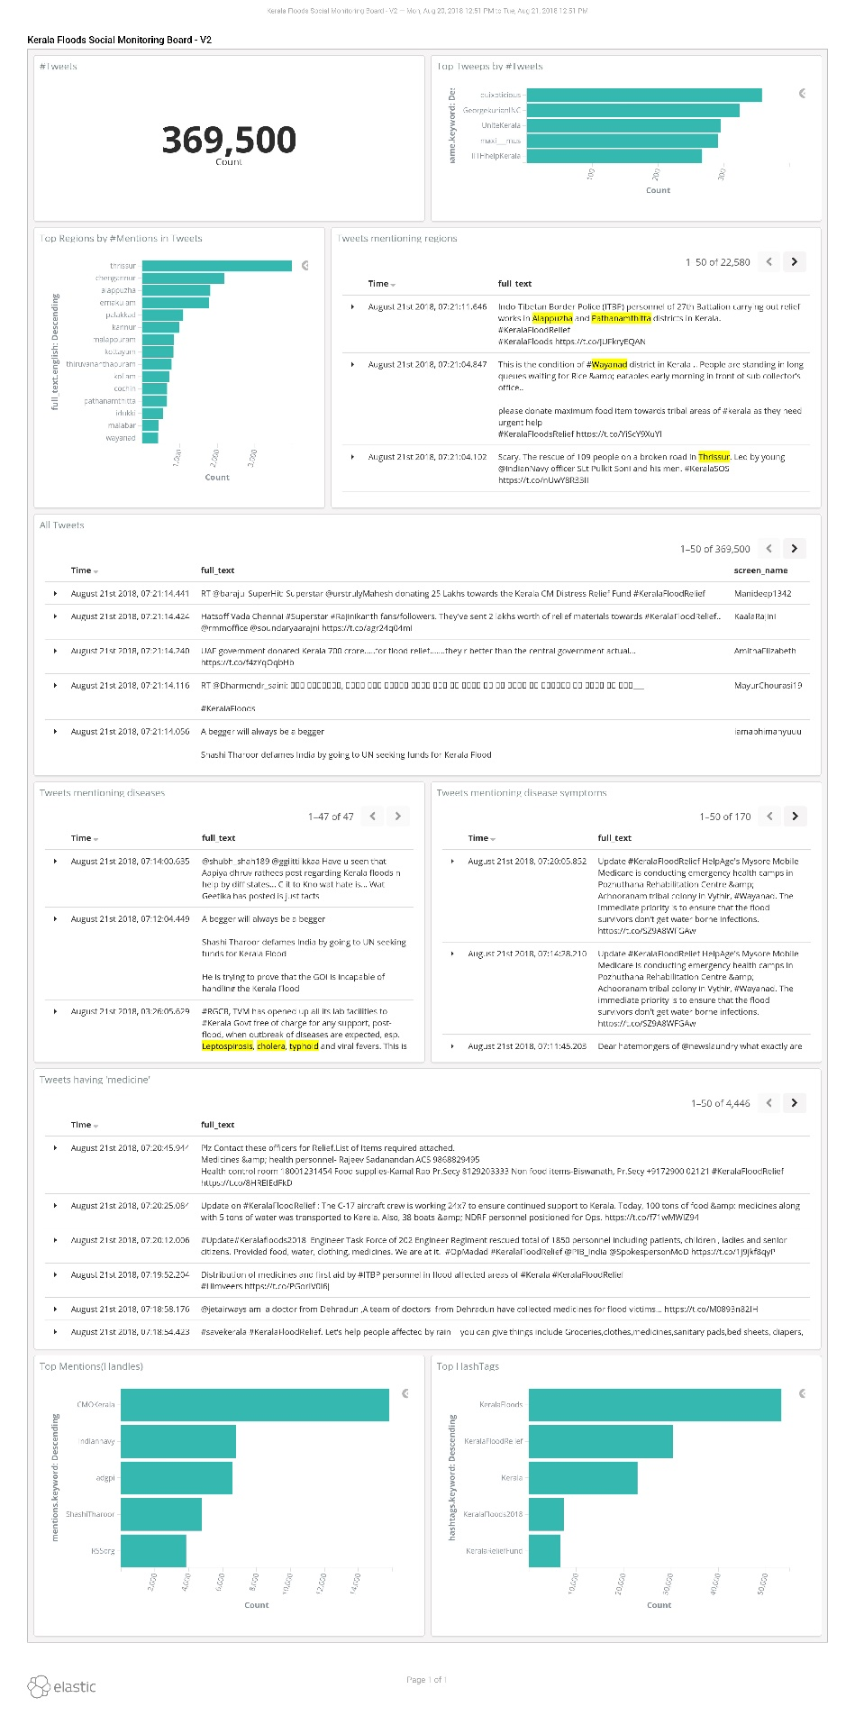

Top hashtags by no. of tweets having them.

List of tweets having ‘medicine’ in them.

List of tweets having disease names.

Chart showing top regions by number of tweets having the region mentioned.

Total tweets

List of all tweets with disease symptoms.

Top user handles (profiles) by no. of tweets.

List of all tweets.

List of raw tweets with region mentioned in them.

Chart showing top tweeps (one who has tweeted) by total number of tweets they have made.

Title of the Chart. Here it is the total no. of tweets.